SPARC - Capital Cost Transfer User Guide

Capital Cost Transfer for Stanford University Property

For use with Stanford property only

Capital Cost Transfer

Log into the Stanford Property Administration Resource Center (SPARC) web portal by typing SPARC.stanford.edu into the address bar.

From the SPARC Home Page click **Capital Cost Transfer** (CCT) title or the small icon to the right of the title. Your view of applications may differ from this example.

From the User dashboard you may access My Drafts, My Outstanding Requests, My Revoked Requests, My Completed Requests, Requests for Financial Approval, and Requests for PMO Approval these tables will contain all information created by the User or routed to them for approvals. These fields default to a minimized view but can be expanded with the down arrow to the left of the Status title.

To create a new capital cost transfer click” Create PO Cost Transfer by clicking on the title in the left-hand side bar. For Non-PO Cost Transfers please reach out to a Property Programs Manager at the Property Management Office for assistance. In the search form below, for a PO Cost Transfer begin typing the PO number and select the desired PO. When field is populated click “Search”.

PO Cost Transfer

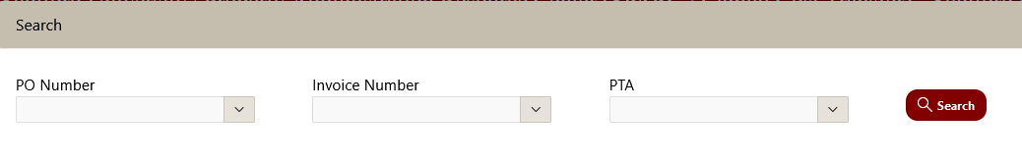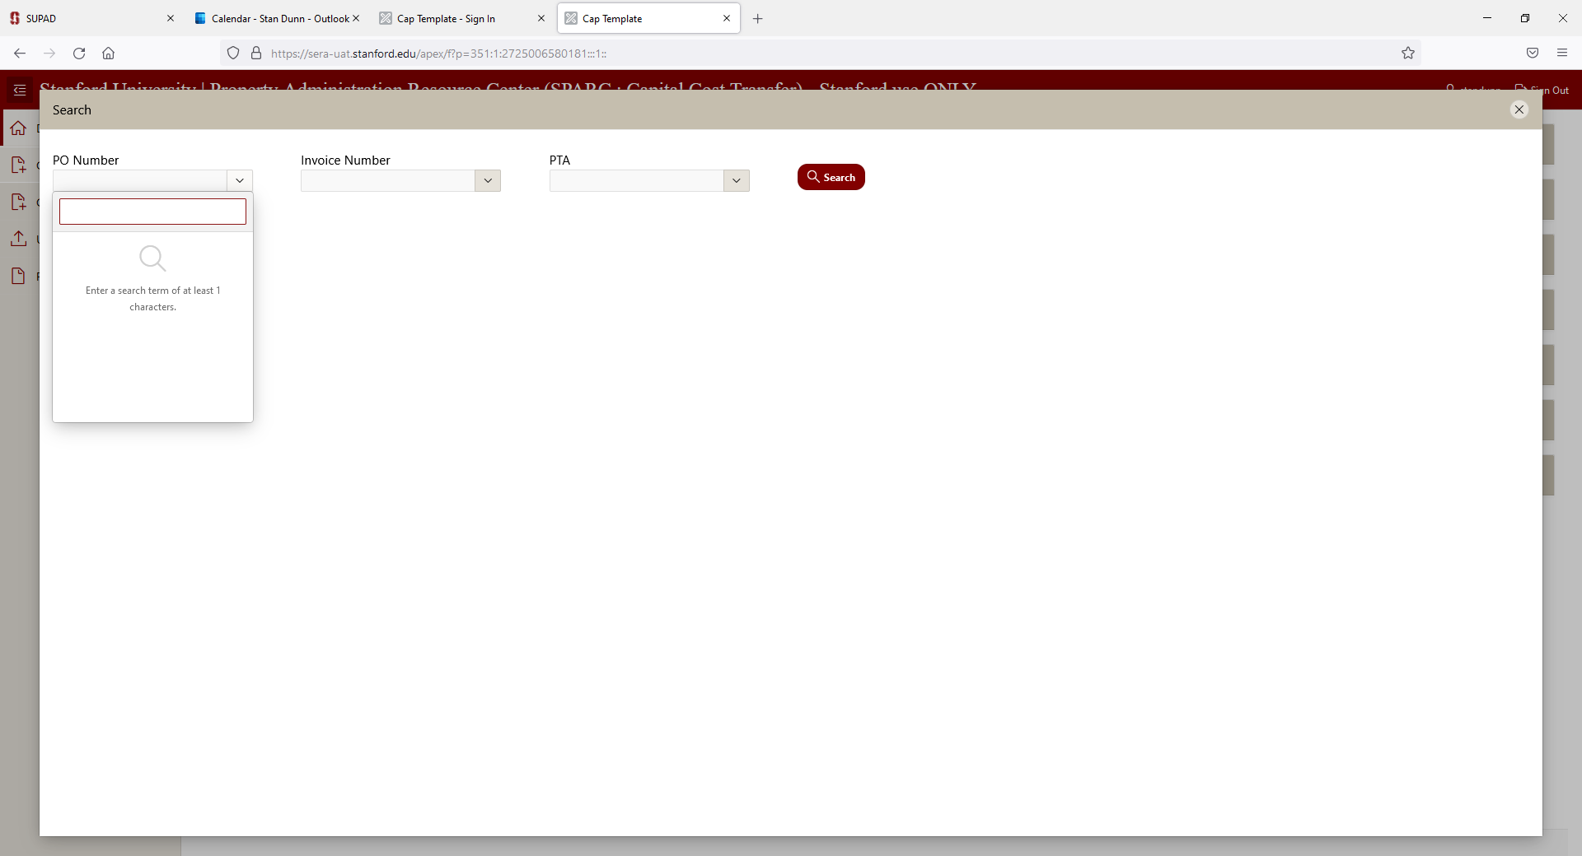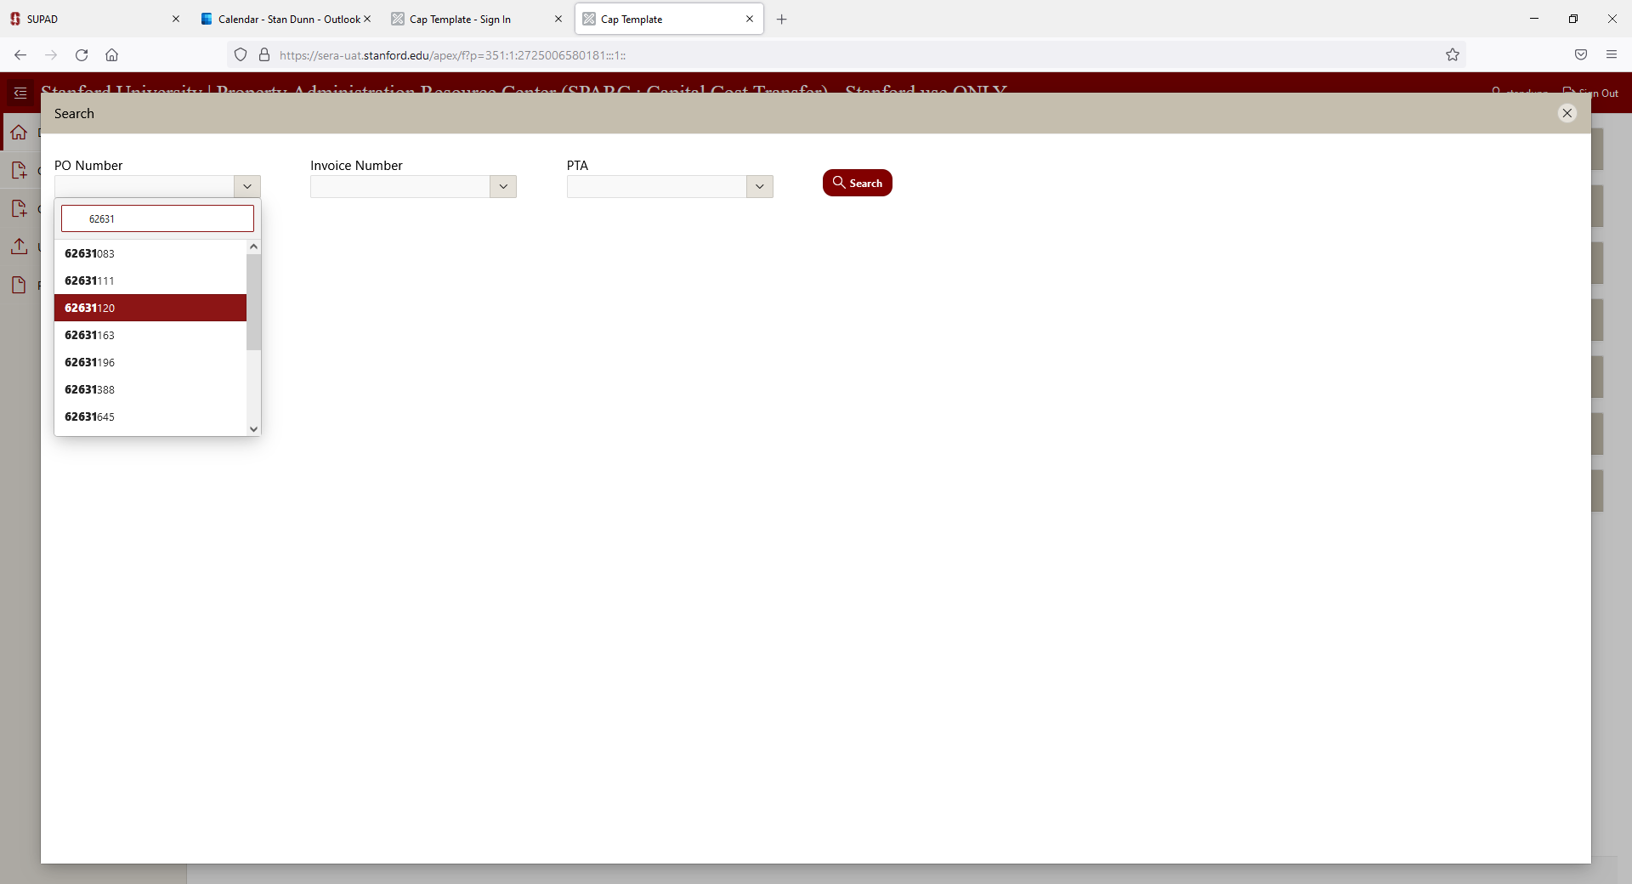

To retrieve a Non-Cap PO or a PO two years or older, click **“Create PO Cost Transfer”** in the sidebar, and enter the PO number as shown. You will get message that it will take overnight retrieval for your selection. Click **“Overnight Data Retrieval”** and that PO will be available next day.

Complete the Originator Contact information, which will auto populate after the first use. Begin typing the DPA name to select your Department DPA. If you are unsure of your DPA, use the SPARC DPA Directory to identify the correct DPA.

The Vendor Number and Site will auto populate from the PO information. Enter a SUID Tag number if applicable and the justification for the transaction, it is required field.

Your PO selection will populate all Original Credit lines automatically. You can begin your transaction by selecting one of the options available.

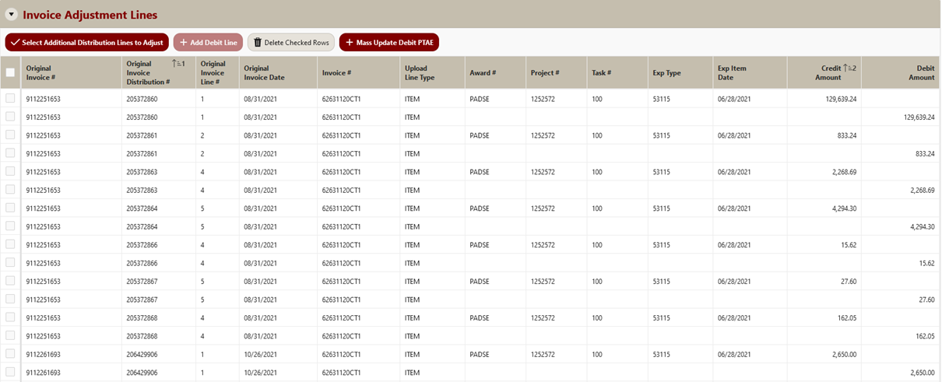

Click **“Add Debit Lines”** to split costs to multiple PTAE.

Click **“Mass Update Debit PTAE**” to change all to a single new PTAE

To add an individual PTAE - enter the Debit information in the line below the credit line you wish to change.

The most common transaction will be the Mass Update Debit PTAE. When you click the Mass Update PTAE button it will open another form.

Select the “Update All” radio button to capture all invoice lines from the PO. Next enter the new Award, Project, Task Number, Expenditure type and the original expenditure date. These values are “nested” and will be limited to those possibilities in the previous selection. Click “Save & Exit” when entered.

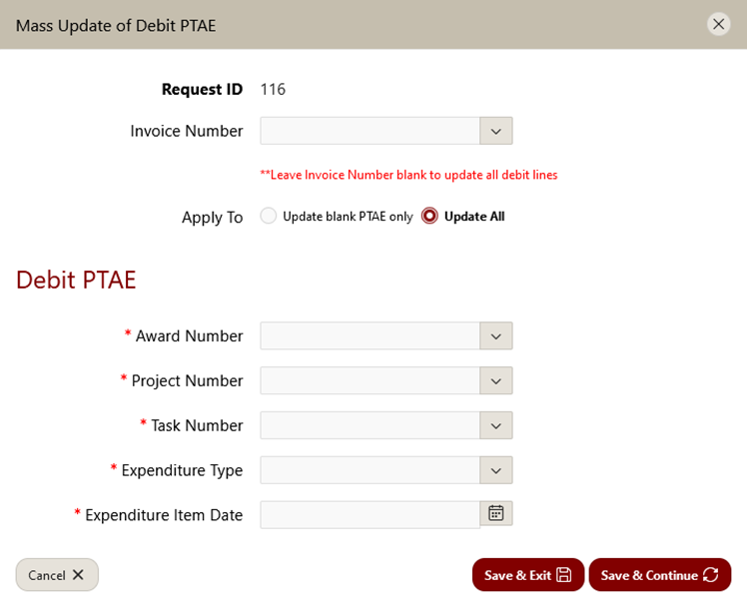

**NOTE:** If you have lines that involve different ETs, such as warranties, maintenance agreements or other non-capital items you can change those individually first and then select “Update blank PTAE only” for this item.

To submit the request, click **“Review Prior to Submit”** or **“Save Changes”** to return to it later. The CCT will be in the My Drafts folder on the User Dashboard if **“Save Changes”** is used.

Mass Updates may also be made to the financial approver. Click **“Mass Update Financial Approver”** for a pop-up box to select the PTAE and Financial Approver for all rows with that PTAE. When complete, click “Save and Exit” to close the pop-up, changes will reflect in the Invoice Adjustment Lines.

After clicking **“Review prior to Submit”** the Final Review page will show all Capital Cost Transfer details.

Note the Pre-Submission status and review details prior to submitting for approval routing. The Financial Approver choice is based on the individual with the approval authority for the account being debited, based on the debit amount – the person with the lowest dollar level authority above that amount is automatically populated. It is recommended that you let the approver know an approval is coming via email.

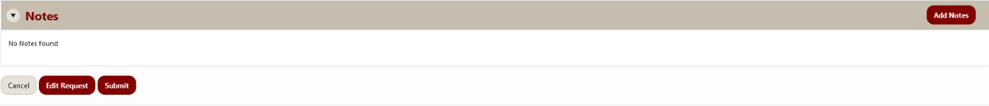

You can also enter notes at the bottom of the Review page, notes will be visible to approvers. You can also click **“Edit Request”** to go back and edit if needed. To submit click **“Submit”** and the request will flow into the Financial Approver(s) Queue.

Financial Approval

Financial Approver logs into SPARC.Stanford.edu, accesses the Capital Cost Transfer application. The Application opens to your personal dashboard page. Transactions you originate will be stored in the history sections. From the dashboard, select Requests for Financial Approval Table

The Financial approver may review originator, DPA and other details by expanding the **Approvals** folder with the down arrow. The **Summary of total paid by PTAE** and **Original Invoice Distribution** lines being modified are also available for review from this page. Once review is complete, **Approve/Reject All** is available or click **Actions** for Approve/Reject individual lines.

Non- PO Capital Cost Transfers

Although there are policy prohibitions against the use of PCards and Reimbursements for capital acquisitions, we all know there are occasional circumstances that arise. The application includes a means for creating a Capital Cost Transfer request on any transaction that is not a Purchase Order.

Select **Non-PO Cost Transacti**on from the side bar and fill in the general information. You will need to look up the vendor(supplier) in the SU Inquiry Tools and Forms in Oracle Financial (ofweb) landing page.

Begin by selecting SU Inquiry Tools and forms then Supplier Query and Request.

When entering the supplier name, you can use wildcards (%) to widen the results. If you cannot find the needed supplier please contact PMO to assist you in completing your Non-PO Cost Transfer.

Then Enter the vendor number and select pay site from the list of values. Enter the SUID tag number if known, as well as the justification.

Credit and Debit lines will need to be created from scratch, click **“Add Line”** to begin.

A new row will be created, and you can select the type of transaction being modified: Invoice (ER), PCard, or iJournal.

Create Debit and Credit Lines by clicking “Add Line” as necessary.

You may now “**Save Changes”** to complete later or click **“Review Prior to Submit**”. As with other transactions, you will have a summary page to review where you can **add notes**, return to **make edits**, or **submit** the transaction for approval routing.

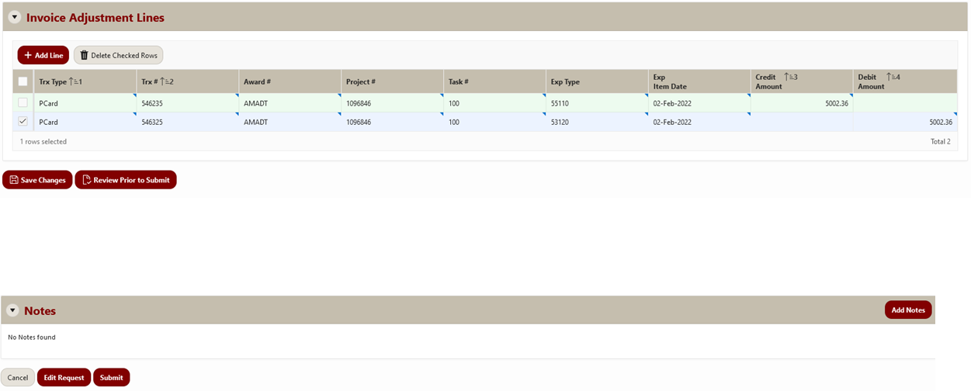

CV

CV

CV

When reviewed click **“Edit Request”** to make changes or **“Submit”** to route your CCT to approver(s).